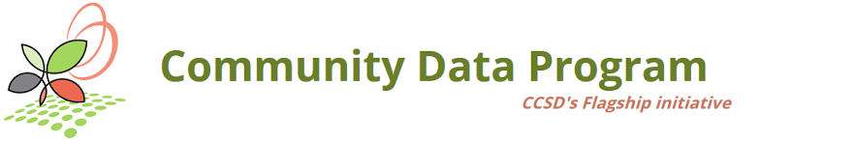

Community Snapshots
  - Let’s share our work
Community Snapshots are a way for CDP members to share how community data is being used. All material provided to CCSD will be used to showcase (1) the use of data by CDP members, (2) the people who analyse the data, and (3) its impact on communities.

To submit a Community Snapshot, send us an email with the fields below filled out.
By submitting a Snapshot, members grant permission to show this content on ccsd.ca. CCSD will maintain an inventory of these submissions.

1. Name of the report, project, initiative, etc.
e.g. Townsville Social Determinants of Health Report

2. Link
e.g. http://townsvillespc.ca/socdetreport.pdf

3. Organization
e.g. Townsville Social Planning Council

4. Picture
Attach a picture showing something about the report, project, initiative, etc. Pictures showing people are preferable, but something else, like the cover page of a report, would also be suitable. Any size and format is fine. For example:
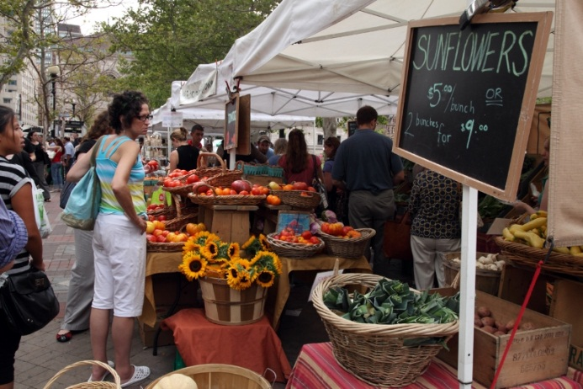

5. Project summary
In a sentence or two, describe the report, project, initiative, etc. For example:
The Townsville Social Determinants of Health Report uses Taxfiler data and NHS data to measure median income amongst neighbourhoods in Townsville. It then overlays this information with local data on food retail locations, in order to uncover areas of Townsville with vulnerable populations that would benefit from better access to fresh fruits and vegetables.

6. Community data used
Provide links to the community data tables you used to undertake this project/initative/report. For example:
- http://communitydata.ca/content/target-group-profile-low-income-population-lim-nhs-2011
- http://communitydata.ca/content/f-18-after-tax-low-income-2011

7. Your picture
Attach a picture of the practitioner(s) who undertook the report, project, initiative, etc. Any size and format is fine. For example:
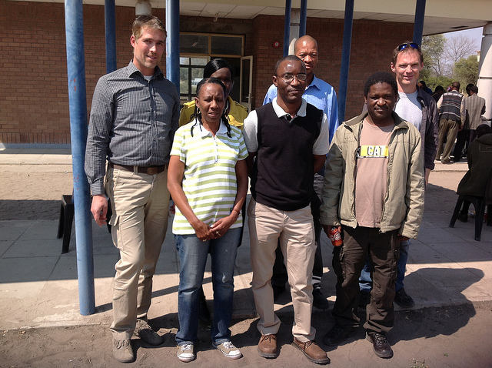

8. About the practitioner
In a sentence or two, describe the person(s) who undertook the report, project, initiative, etc. For example:
Claire Barnes is the Senior Policy Analyst at the Townsville Social Planning Council. She worked with intern Frank Underwood to develop the Townsville Social Determinants of Health Report.
--

Send the filled out fields to information@communitydata.ca.

